Core Values Judging and Poster

Core Values Judging
Your Core Values judging session will have the following format:
At Los Angeles Region FLL Qualifying Tournaments:
- 2 minutes (maximum) – Core Values Poster (described below): When your team enters the judging room, they will be given up to two (2) minutes to present and describe poster content.
- 8 minutes – Questions and Answers: Time reserved for the Core Values judges to ask questions about the Poster and the season.
At Los Angeles Region FLL Championship Tournament:
- 5 minutes – Teamwork Activity: When your team enters the judging room, they will be given a short, fun activity while the judges observe how the team works together.
- 2 minutes (maximum) – Core Values Poster (described below): Following the teamwork activity, your team will be given up to two (2) minutes to present and describe poster content.
- 5 minutes – Questions and Answers: Time reserved for the Core Values judges to ask questions about the Teamwork Activity, the Poster and the season.

Core Values Poster
To help the Core Values judges learn more about your team and its unique story, we are requiring every team to complete a Core Values “tri-fold” or poster. The topics highlighted on the poster are typically the most complex to discuss during judging sessions. The poster is intended to help your team consider in advance how best to share these elements so that the judges can fairly assess all teams and have the best information possible when determining award winners.
Important rules and guidelines are listed below:
- Time Investment: While your team is free to determine how much time to spend, a realistic expectation for most teams is 4 to 8 hours from initial discussion to completion; this poster is NOT intended to be on the same scale as your Project presentation. Remember the judges are only interested in your team’s story, not fancy graphics.

- General Layout: The poster layout should follow the diagram below. The overall size of the poster should be as shown, although it may be smaller if required by travel needs. The poster may also be rolled or assembled on site.
[Diagram on next page]
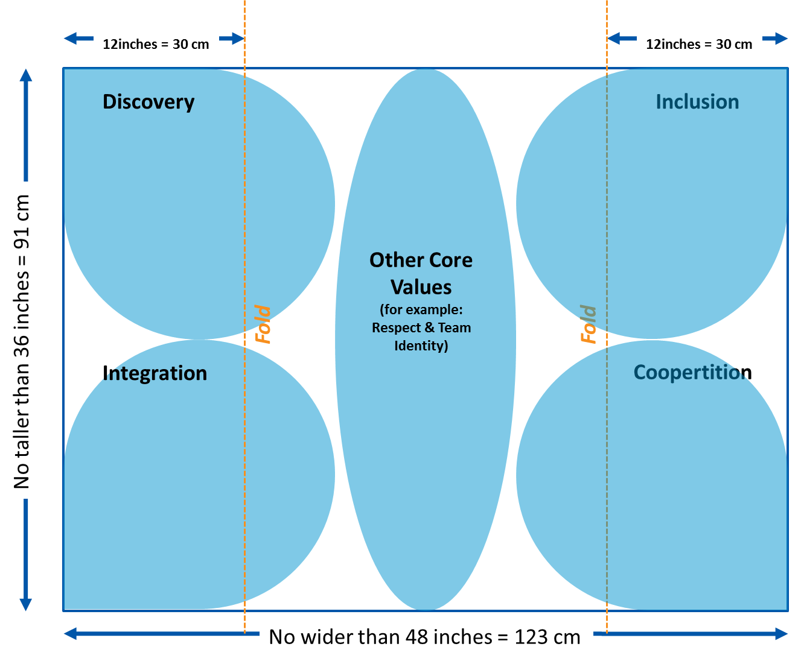
- Defined areas: There are four areas on the poster where specific information should be provided. These are the MOST IMPORTANT areas of the poster and should be the main focus of your work.
  - In the “Discovery” area of the poster, provide examples from the season about things your team discovered that were more about gaining knowledge than about gaining an advantage in the competition or winning an award. Tell the judges how you balanced all three parts of FLL, especially if you really wanted to focus on only one sometimes!
  - In the “Integration” area, provide specific examples of how your team applied Core Values and other things you learned through FLL, to situations outside of FLL. Tell the judges your stories about how you integrated new knowledge, skills and abilities into your everyday life.
  - In the “Inclusion” area, describe how your team incorporated ideas from everyone and made each team member feel like a valued part of the team. Help the judges understand how working together you accomplished more than you could by working alone.
  - In the “Coopertition” area, describe how your team honors the spirit of friendly competition, including any assistance provided or received from other teams. Tell the judges how your team helps each other, and other teams, prepare for and approach potentially stressful competition experiences during your season.

- The Middle: The area in the middle of the poster is for your team to highlight anything else you choose about the remaining criteria on the Core Values rubric: Team Spirit, Respect or any of the Teamwork elements. You may also include examples of how your team has fun or shares with others how amazing science, technology, engineering and math can be. Feel free to use your creativity and expression!

- When complete, please take a photo of your poster to leave with the Core Values judging team.

